#### **Aim:** Predict whether or not it will rain tomorrow by training a prediction model on target variable RainTomorrow

#### **Description**: This dataset contains daily weather observations from numerous Australian weather stations.

The target variable RainTomorrow means: Did it rain the next day? Yes or No.

#### **Data Selection**:

We have downloaded the dataset ( [weather dataset](https://www.kaggle.com/jsphyg/weather-dataset-rattle-package) ) of Australian weather stations which contains about 10 years of daily weather observations from numerous Australian weather stations.

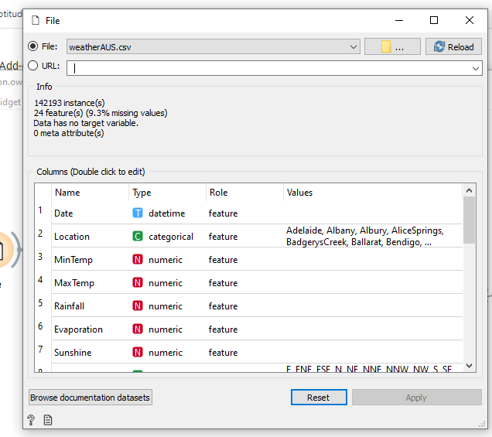

#### **Data Cleaning**:

In data cleaning, we will select the required column and remove the rows with missing values as shown below:

**Column Selection**

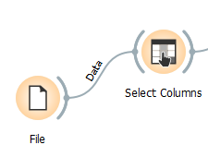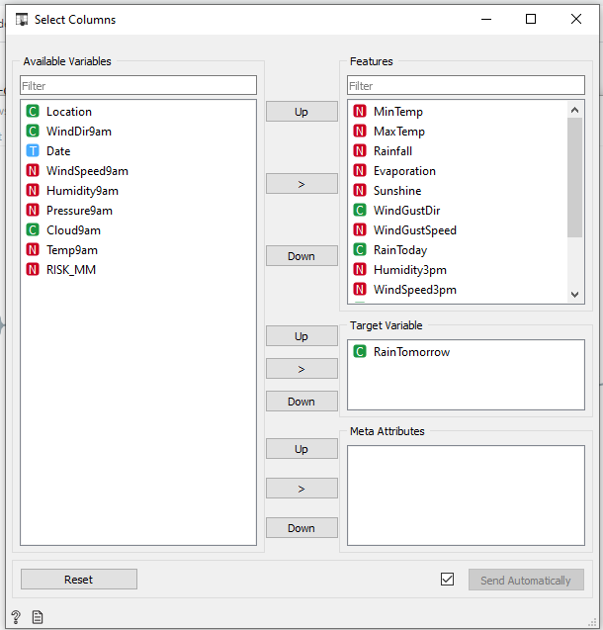

**Removing rows with missing values**

We will use the impute function to remove rows with missing values for columns “Sunshine” and “Evaporation”

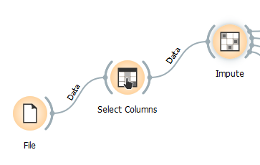

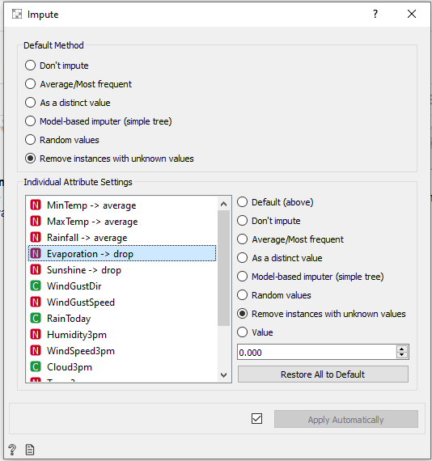

#### **Data Visualization**

In this step, we see the reflected data selection in data table. Then, we use scatter plot to visualize the data for better understanding of our dataset.

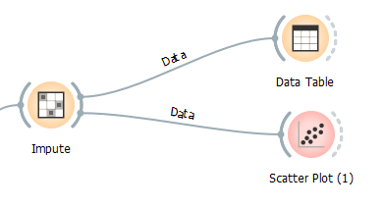

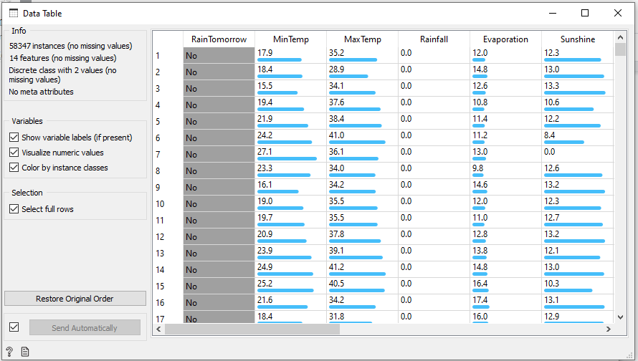

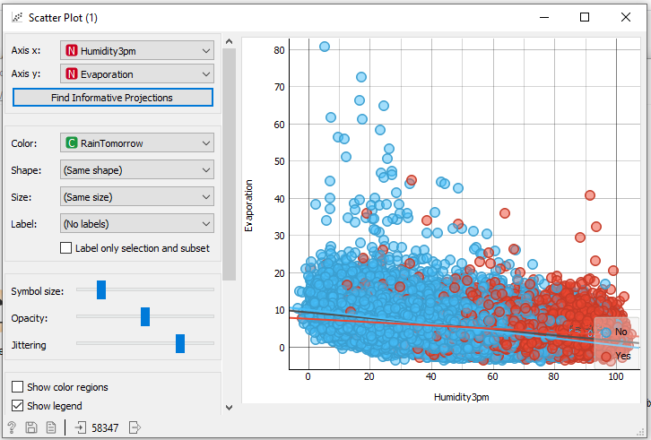

In the above scatter plot we see, as the humidity level increases and evaporation rates are low the chances of rainfall increases (red dots)

#### **Data Modeling**

In this step, we use **Logistic regression** to model our data. Then, we use “test and score” function to evaluate the performance of our model. Finally, we use “confusion matrix” to understand the prediction.

